Wrapper classes :

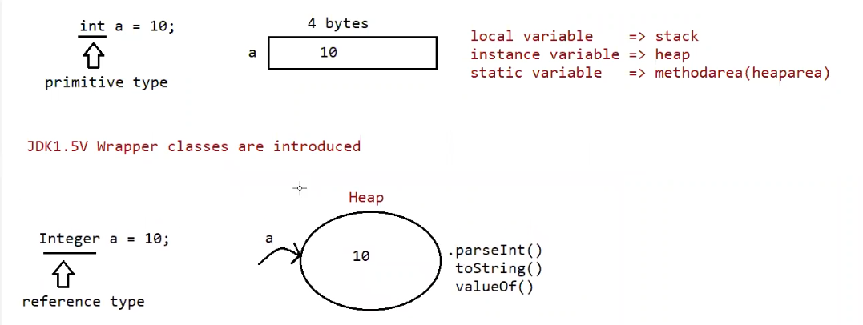

When we create a variable of primitive data type , memory for it is assigned based on whether it is local , instance, static variable.

But when we create a variable of wrapper class the , memory is not allocated as primitive data type , instead a object will be created and data is stored in the object.

The reason for using wrapper classes is it creates object , and with that reference of the object we can call some methods eg: .parseInt() , .toString() , .valueOf() ( to check all the supported methods use command javap java.lang.Integer )

Since the body for methods is already available we can call them as utility methods, and classes as helper classes.

For every class parent happens to be Object , but for wrapper classes the parent happens to be Number class ,And Object is the parent of Number class

toString() is present in object class. ( to string() returns the hashcode value of the object )

if you are trying to keep the data in the string and if that data is not of integer type, then it would result in the Number Format Exception.

Purpose of wrapper classes :

To wrap primitives into object form ,so that we can handle primitives also just like objects.

To define several utility functions which are required for the primitives

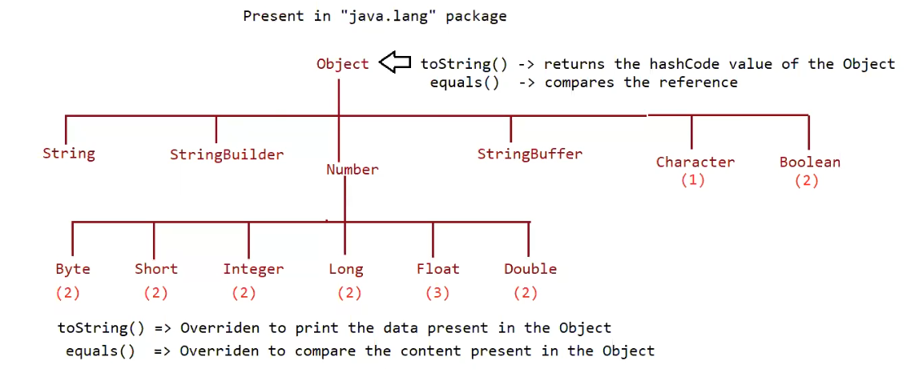

* Almost all the wrapper classes have 2 constructors eg: Byte , Short , Integer , Long , Float , Double.
* But Character and Boolean have only 1 constructor.
* Almost for all the user defined and predefined classes the parent is Object class.
* But for Byte , Short , Integer , Long , Float , Double wrapper classes the parent is Number class.
* Object class contains the toString() , equals() that have above functionality.
* The methods can be overridden by classes and they may have some other functionality .

Example equals() of String class compares the content not the reference.

* The toString() method of wrapper classes are overridden and have the above functionality.

Constructors (check using the command javap java.lang.Integer , and for remaining wrapper classes use the above command just the name after lang.Wrapper_Class_Name )

1. One taking primitive type

eg: public java.lang.Integer(int);

Integer a = new Integer(10);

1. One taking String type

Eg: public java.lang.Integer(java.lang.String) throws java.lang.NumberFormatException;

Integer a1 = new Integer(“10”);

Note: If String argument is not properly defined then it would result in RunTimeException called “NumberFormatException”

Eg: Integer I = new Integer(“ten”) // RuntimeException : NumberFormatException .

Wrapper class and its associated constructor

Note : check every class constructors by javap java.lang.Wrapperclass_Name

Byte => byte and String

Short => short and String

Integer => int and String

Eg: Integer_Constructors // go through the code.

Long => long and String

Float => float, double and String

Eg: Float_Constructors // go through the code

// after going through the code check this link.

// <https://docs.oracle.com/javase%2F9%2Fdocs%2Fapi%2F%2F/java/lang/Float.html>

Double => double and String

Character => character

Eg: Character_Constructors // go through the constructors

Boolean => boolean and String

Eg: Boolean_Constructors

Note :

Incase of Boolean constructor , boolean value is treated be treated as true w.r.t to case insensitive part of “true” , for all others it would be treated as “false”.

Note:

If we are passing String argument then case is not important and content is not important

If the content is case insensitive String of true , is treated as true in all other cases it is treated as false.

Note:

Incase of wrapper class , toString() is overridden to print the data.

Incase of wrapper class , equals() is overridden to check the content.

Just like String class , Wrapper classes are also treated as “immutable class”.

Eg: Interger_Equals_Method

// go through the code

Can we make our user defined class immutable ?

Yes , shown as below .

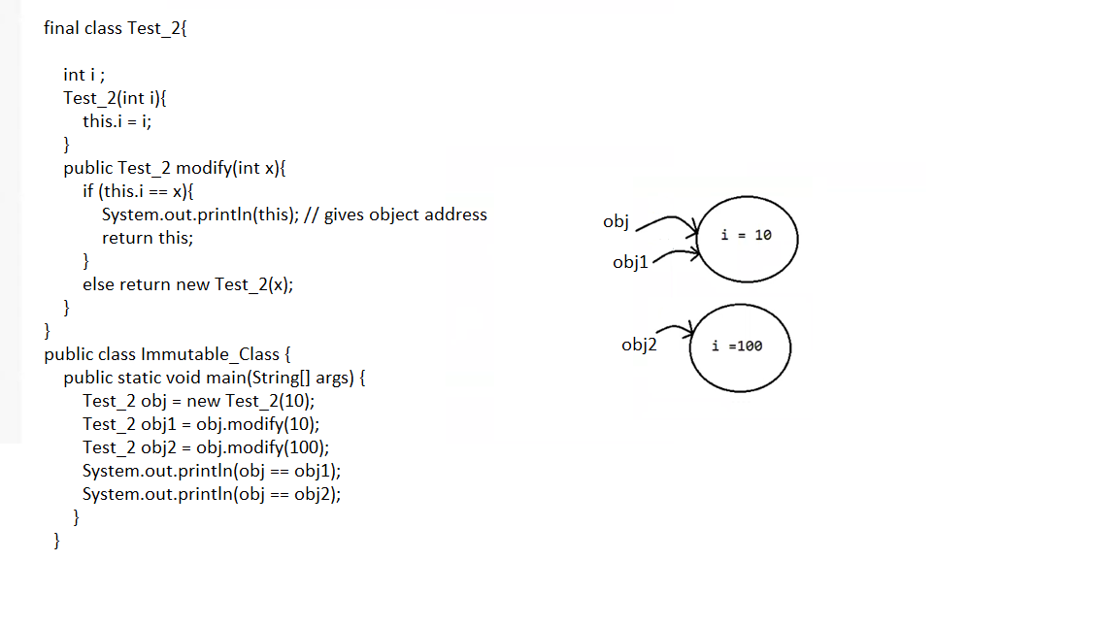

Wrapper classes and string classes are immutable ( immutable means if you try to make a change to the object with that change a new object is created )

toString() => prints the content of the object

equals() => compares the data present in the object

// both the methods works same in String , wrapper classs.

Note: Methods which are static are said to be helper methods (or) utility methods.

Wrapper classes utility methods :

1. valueOf() method
2. XXXvalue() method
3. parseXxx() method
4. toString() method

( javap java.lang.Wrapper_ClassName will give the utility methods .)

public static Wrapper valueOf (String data, int base (or) radix) throws java.lang.NumberFormatException;

public static Wrapper valueOf ( String data ) throws java.lang.NumberFormatException;

public static Wrapper valueOf (int);

valueOf() method :

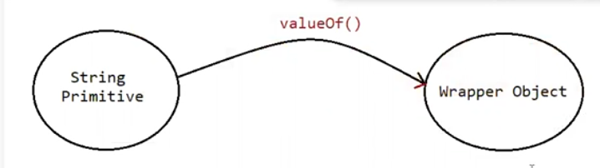

To create a wrapper object from primitive type (or) String type we use valueOf() method

It is an alternative to constructor of Wrapper class , not suggestable to use.

Every wrapper class , except character class contain static valueOf() method to create wrapper object.

Eg: ValueOf_Method

// go through the code

Eg: ValueOf_Method_Eg2

// go through the code

Eg:ValueOf_Method_Base

// learn number systems and then check this.

public static valueOf(String s , int radix)

|=> binary : 2(0,1)

<https://www.youtube.com/watch?v=sXxwr66Y79Y>

Note : Except binary , working procedure of all the remaining number systems are same.

Not only this mentioned number systems java supports 2,3,4,5,6,7,8,9,10,11,12,13…… 36 number systems .

| => octal : 8(0-7)

https://www.youtube.com/watch?v=XHXNUHMQ1IM

|=> decimal : 10(0-9)

// https://www.youtube.com/watch?v=G4doTGQPRPw

|=> hexadecimal : 16(0-9,a,b,c,d,e,f)

// a=10, b=11 ….. f = 15

|=>base : 36(0-9,a-z)

// a=10, b=11 ….. z= 35

Note : the minimum and maximum base we can give is

Eg: Min_Max_Radix // go through the code

Eg:ValueOf_Eg3

// check valueOf() method For Boolean , Character takes which types of arguments

javap java.lang.Boolean

javap java.lang.Character

// go through the code

2. xxxValue()

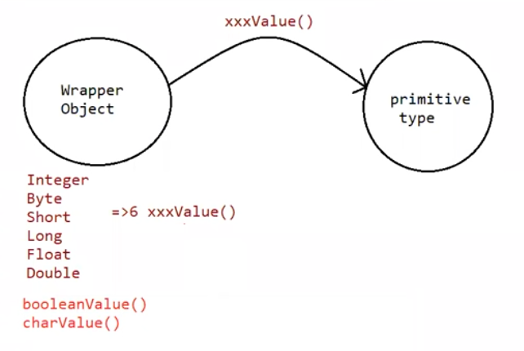

We can use xxxValue() to get primitive type for the given wrapper object.

These methods are a part of every Number type Object.

(Byte,Short,Integer,Long,Float,Double) all these classes have these 6 methods which is

Methods:

public byte byteValue();

public short shortValue();

public int intValue();

public long longValue();

public float floatValue();

public double doubleValue();

Eg: Integer_Value_Method

// go through the code

Character class has charValue() to get character primitive for given character object.

public char charValue()

Eg:Character_Value_Method

Boolean class has booleanValue() to get boolean primitive for given boolean object.

public boolean booleanValue()

Eg: Boolean_Value_Method

In total xxxValue() are 36 in number

xxxValue() => convert the wrapper object => primitive

3. parseXXX() :

We use parseXXX() to convert String Object into primitive type

Form-1 :

public static primitive parsexxx( String s)

Every wrapper class except Character class has parseXXX() to convert string to primitive

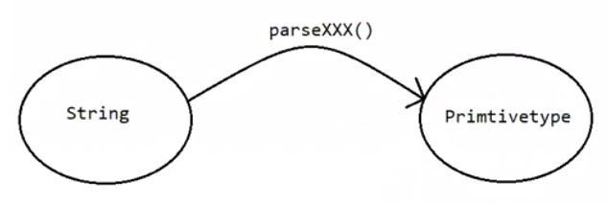

Eg: Parse_Method_Eg1

Usage of wrapper class in real time coding :

Eg: Wrapper_Class_Parse_Method_RealTime_Usage

Note : The command line arguments are taken as String in java program , because the string input from user can be converted to all types of primitives except char .

You can pass character in command line , but it is treated as String only . there is no parse method to convert String to character primitive.

Form-2 :

public static primitive parsexxx( String s , int radix )

radix -> range is from 2 to 36.

Every Integral type wrapper class ( Byte , Short , Integer, Long) contains the following parseXXX(String s, int radix) to convert specified radix string to primitive

// check javap java.lang.Wrapperclass

Eg: Parse_Method_Radix

toString() :

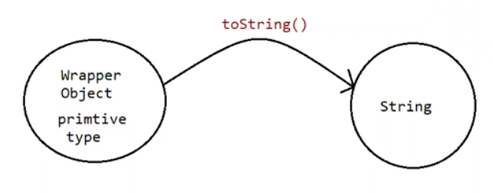

To convert the wrapper object (or) primitive to string

Every wrapper class contain toString() method.

From1 :

public String toString()

1. Every wrapper class ( including the Character class ) contain the above toString() , to convert wrapper object to String.
2. It is the overriding version of Object class toString() method.
3. Whenever we are trying to print wrapper object reference toString() method is automatically called.

Eg: Integer a = Integer.valueOf(“10”);

Sysytem.out.println(a) // internally it calls toString() and prints the data.

Form2 :

public static String toString(primitive)

1. Every wrapper class contain a static toString() method to convert primitive to string.

eg: String s = Integer.toString(10);

Eg: Primitive_ToString

Form 3 :

Integer and Long classes contains the following static toString() to convert the primitive to specified radix String form.

public static String toString (primitive p , int radix)

Eg: Primitive_Radix_ToString

Form 4:

Integer and Long classes contains the following toXxxString() methods.

public static String toBinaryString(primitive p)

public static String toOctalString(primitive p)

public static String toHexString(primitive p)

Eg: ToString_For_Binary_Octal_Hex

valueOf() -> String / primitive to wrapper object.

XXXValue() -> wrapper to primitive

parseXXX() -> String to primitive

toString() ,toHexString() , toBinaryString() , toOctalString() -> primitive to String.

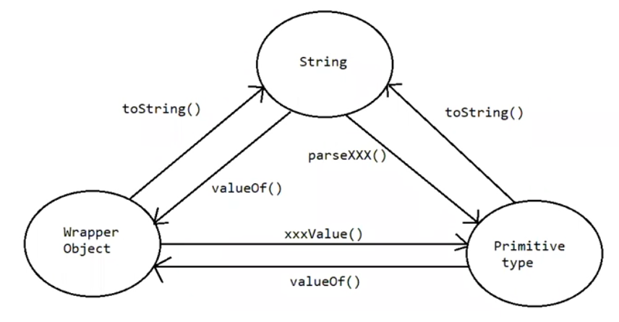

Note :

String class

public static String valueOf(boolean);

public static String valueOf(char);

public static String valueOf(int);

public static String valueOf(long);

public static String valueOf(float);

public static String valueOf(double);

String data = String.valueOf(‘a’); // static factory methods

Here we are performing operations on String and output is also string type we call them as factory methods.

String data = “pavan”.toUpperCase(); // instance factory methods

Here we are performing operations on StringObject and output is also string type we call them also factory methods.